How to comment on the online discussion page

Thank you for wanting to participate in our online discussion! Please follow the guide below if you wish to get more precisions on how to post in the discussion. We hope to get as many contributions as possible, therefore, if you ever have any trouble connecting, please contact Annelise Thim using this address: annelise.thim@oecd.org.

1) First, go to the bottom of the online discussion page. This is what you see.
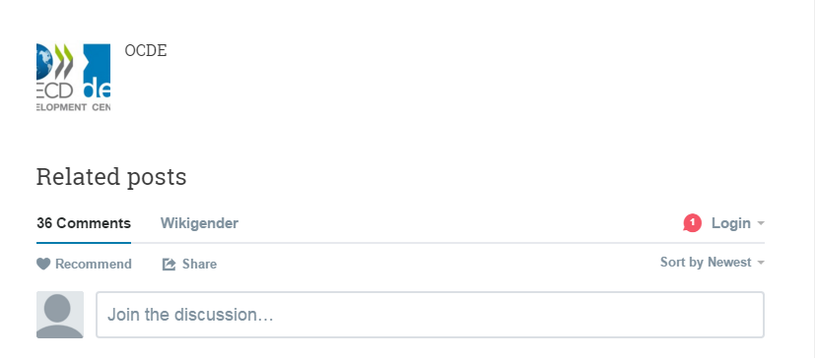

2) When you first click on the “Join the discussion” box, you have two options. You can either log in with your Facebook, Twitter or Google Account, or you can sign up with Disqus.
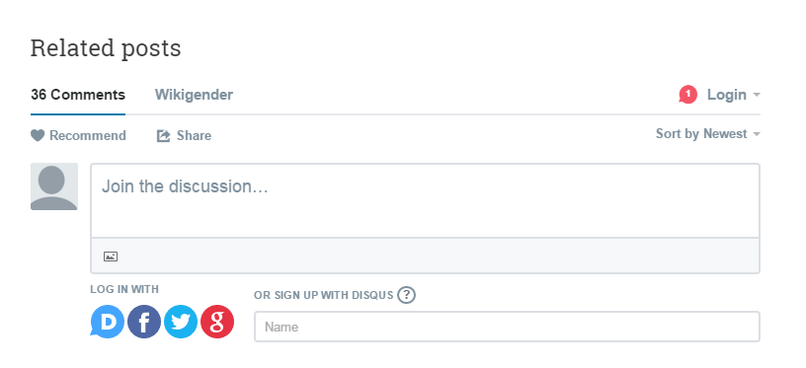
3) If you choose “Sign up with Disqus”, this is what you will see. You will be asked to provide your name, email, and choose a password. You can also tick the “I’d rather post as a guest” box if you wish to do so.
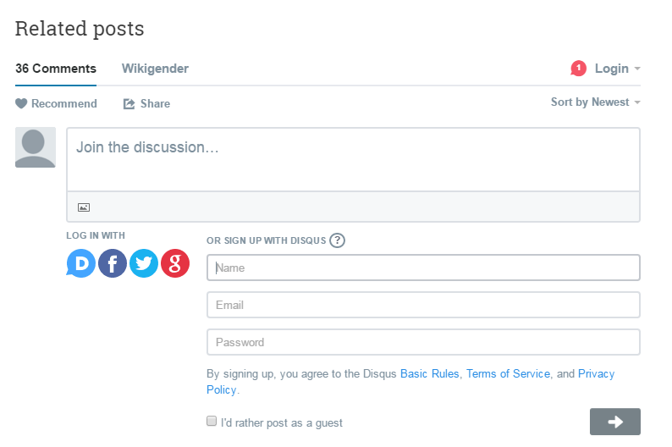
4) If you do choose to post as a guest and tick the box, you will only be asked to provide a name (that can be a pseudo) and an email. You will not be spammed as a result and your address will not be used by Disqus. Once you post your comment, it might take some time to appear in the discussion as it needs to be checked by our moderator.
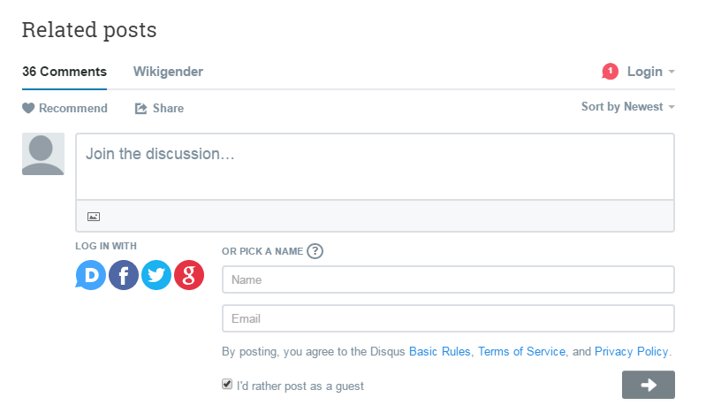

We look forward to reading your contributions !

